VHLST 10T

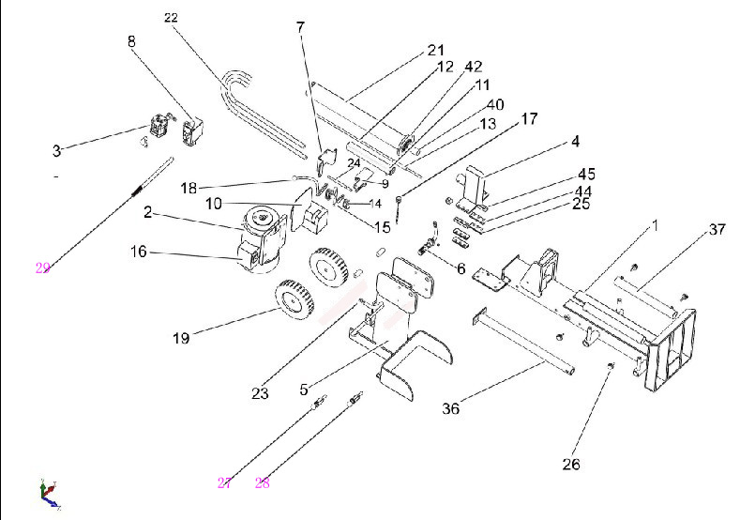

Part No. |  | Description | Qty
1 | VHLS10T-1 | Work Table Welding Unit | 1
2 | VHLS10T-2 | Motor | 1
3 | VHLS10T-3 | Pump | 1
4 | VHLS10T-4 | wedge | 1
5 | VHLS10T-5 | Oil Tank | 1
6 | VHLS10T-6 | Filter | 1
7 | VHLS10T-7 | Valve Seat | 1
8 | VHLS10T-8 | Double Speed Valve | 1
9 | VHLS10T-9 | Valve Pressing Plate | 1
10 | VHLS10T-10 | Control Box | 1
11 | VHLS10T-11 | Block Pipe | 1
12 | VHLS10T-12 | Block Rod | 1
13 | VHLS10T-13 | Adjusting Pipe | 1
15 | VHLS10T-15 | Operation Handle | 2
16 | VHLS10T-16 | Switch | 1
17 | VHLS10T-17 | Oil Level Indicator | 1
18 | VHLS10T-18 | Operation Ball M6x20 | 2
19 | VHLS10T-19 | Wheel | 2
21 | VHLS10T-21 | Cylinder Assembly | 1
22 | VHLS10T-22 | Hi-Pressure Hose | 3
23 | VHLS10T-23 | Rubber Hose | 2
24 | VHLS10T-24 | Block Pin | 1
25 | VHLS10T-25-44 | Guiding Support | 2
26 | VHLS10T-26 | Plum handle | 4
27 | VHLS10T-27 | Upper bolt | 2
28 | VHLS10T-28 | Lower bolt | 2
29 | VHLS10T-29 | handle | 1
36 | VHLS10T-36 | Support leg | 1
37 | VHLS10T-37 | Wood supporting frame | 2
40 | VHLS10T-40 | Piston rod | 1
42 | VHLS10T-42 | Flange For Cylinder | 1
44 | VHLS10T-25-44 | Lower Guiding | 2
45 | VHLS10T-25-44 | Guiding liner | 2
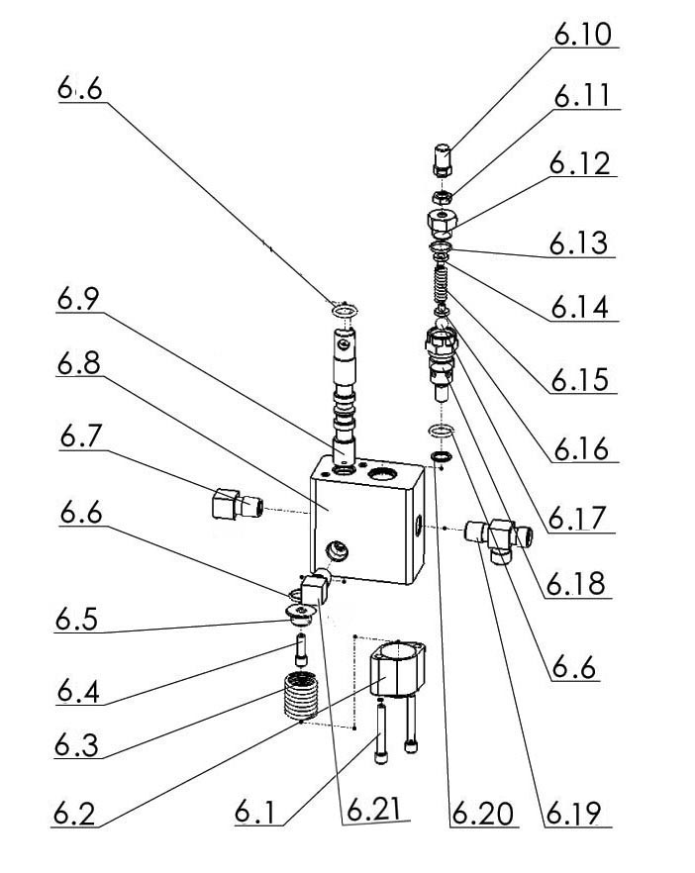
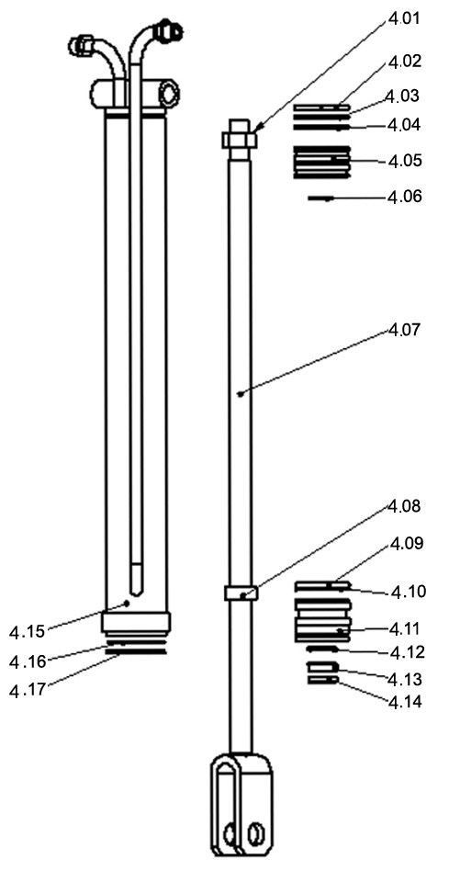

NO. |  |  | Name | Qty
Piston rod assembly | 4.01 | VHLS10T-4.01 | Nut M24X2 | 1
Piston rod assembly | 4.02 | VHLS10T-4.02-4.06 | Belt | 1
Piston rod assembly | 4.03 | VHLS10T-4.02-4.06 | GasketΦ70 | 1
Piston rod assembly | 4.04 | VHLS10T-4.02-4.06 | “O” ringΦ70X3.1 | 1
Piston rod assembly | 4.05 | VHLS10T-4.02-4.06 | Piston (moving end) | 1
Piston rod assembly | 4.06 | VHLS10T-4.02-4.06 | “O” ringΦ20 | 1
Piston rod assembly | 4.07 | VHLS10T-4.07 | Piston | 1
Piston rod assembly | 4.08 | VHLS10T-4.08 | Bush | 1
Piston rod assembly | 4.09 | VHLS10T-4.09-4.14 | “O” ringΦ70 | 1
Piston rod assembly | 4.10 | VHLS10T-4.09-4.14 | Stopper Φ70 | 1
Piston rod assembly | 4.11 | VHLS10T-4.09-4.14 | Piston (fixing end) | 1
Piston rod assembly | 4.12 | VHLS10T-4.09-4.14 | Seal ring STM-03-22 Φ28 | 1
Piston rod assembly | 4.13 | VHLS10T-4.09-4.14 | Seal ringΦ28
Piston rod assembly | 4.14 | VHLS10T-4.09-4.14 | Dustproof ringΦ28 | 1
Piston rod assembly | 4.15 | VHLS10T-4.15 | Hydraulic cylinder column | 1
Piston rod assembly | 4.16 | VHLS10T-4.16 | StopperΦ70 | 1
Piston rod assembly | 4.17 | VHLS10T-4.17 | StopperΦ65 | 1
Direction exchanging valve assembly | 6.1 | VHLS10T-6.01 | M6x45 inner six angle Bolt | 2
Direction exchanging valve assembly | 6.2 | VHLS10T-6.2-6.18 | Valve front cover | 1
Direction exchanging valve assembly | 6.3 | VHLS10T-6.2-6.18 | Spring Ø3x45 | 1
Direction exchanging valve assembly | 6.4 | VHLS10T-6.2-6.18 | M6x15 inner six angle bolt | 1
Direction exchanging valve assembly | 6.5 | VHLS10T-6.2-6.18 | Spring bush | 1
Direction exchanging valve assembly | 6.6 | VHLS10T-6.2-6.18 | “o” ring Ø22x2.4 | 3
Direction exchanging valve assembly | 6.7 | VHLS10T-6.7 | G3/8”xM18 straight angle curly head | 1
Direction exchanging valve assembly | 6.8 | VHLS10T-6.8 | Valve | 1
Direction exchanging valve assembly | 6.9 | VHLS10T-6.9 | Valve rod | 1
Direction exchanging valve assembly | 6.10 | VHLS10T-6.2-6.18 | Adjusting bolt | 1
Direction exchanging valve assembly | 6.12 | VHLS10T-6.2-6.18 | M8 screw cap | 1
Direction exchanging valve assembly | 6.13 | VHLS10T-6.2-6.18 | Abnormal screw cap | 1
Direction exchanging valve assembly | 6.14 | VHLS10T-6.2-6.18 | “O” ring | 1
Direction exchanging valve assembly | 6.15 | VHLS10T-6.2-6.18 | Spring cover | 1
Direction exchanging valve assembly | 6.16 | VHLS10T-6.2-6.18 | Unloading press spring | 1
Direction exchanging valve assembly | 6.17 | VHLS10T-6.2-6.18 | Sealed steel ball | 1
Direction exchanging valve assembly | 6.18 | VHLS10T-6.2-6.18 | Unloading valve axle core | 1
Direction exchanging valve assembly | 6.19 | VHLS10T-6.19 | Three-way joint | 1
Direction exchanging valve assembly | 6.20 | VHLS10T-6.20 | Sealed cupreous washer | 1
Direction exchanging valve assembly | 6.21 | VHLS10T-6.21 | M6x45 inner six angle Bolt

